A

REPORT BASED

ON

**SUBMITTED IN PARTIAL FULFILLMENT FOR THE AWARD OF DEGREE OF**

**BACHELOR OF ENGINEERING**

IN

**INFORMATION TECHNOLOGY**

BY

**FAIZAN FAROOQUI (160122737118)**

**K.ABHIRAM (160122737111)**

**VENU MADHAV (160122737121)**

UNDER THE GUIDANCE OF

**DR. M .KRISHNA SUREDDI,**

ASSISTANT PROFESSOR,

DEPT. OF IT, CBIT.



**DEPARTMENT OF INFORMATION TECHNOLOGY**

**CHAITANYA BHARATHI INSTITUTE OF TECHNOLOGY (A)**

**(Affiliated to Osmania University; Accredited by NBA and NAAC, ISO 9001:2015 Certified Institution), GANDIPET, HYDERABAD – 500 075**

**Website: www.cbit.ac.in**

**2023-2024**

**INTRODUCTION**

**1.Understanding Demand Patterns:** Uncovering the temporal and spatial distribution of taxi trips to identify peak hours, high-demand areas, and seasonal fluctuations in rider activity.

**2.Optimizing Resource Allocation:** Leveraging geospatial analysis to pinpoint congestion hotspots, optimize driver deployment, and streamline route planning for improved efficiency and service reliability.

**3.Enhancing Customer Experience:** Analyzing fare structures, trip durations, and customer preferences to tailor service offerings, pricing strategies, and promotional initiatives that resonate with diverse customer segments.

We aim to empower taxi service providers, policymakers, and stakeholders with actionable insights that foster innovation, sustainability, and inclusivity within the urban transportation landscape. Through collaborative efforts and data-driven decision-making, we can chart a course towards a future where taxi services are not only accessible and affordable but also seamless, efficient, and responsive to the evolving needs of urban dwellers.

**DATA SET ANALYSIS**

The purpose of the analysis is to examine Uber trip data to identify patterns and trends in ride-sharing activity. By analyzing the data, we aim to understand trip frequency across different times of the day and days of the week, as well as observe the geographical distribution of trips. This analysis can help provide insights into peak usage times, popular areas for rides, and potential areas for service improvement. Ultimately, the analysis will inform decision-making for operational efficiency and customer satisfaction.

Dataset used:

The analysis uses a dataset containing Uber trip data. The dataset includes the following columns:

●Date/Time: The date and time when each trip took place.

●Longitude: The longitude coordinates of the trip's pickup location.

●Latitude: The latitude coordinates of the trip's pickup location.

●Base: The base code associated with each trip, indicating the dispatch location or service hub.

Example of the dataset:

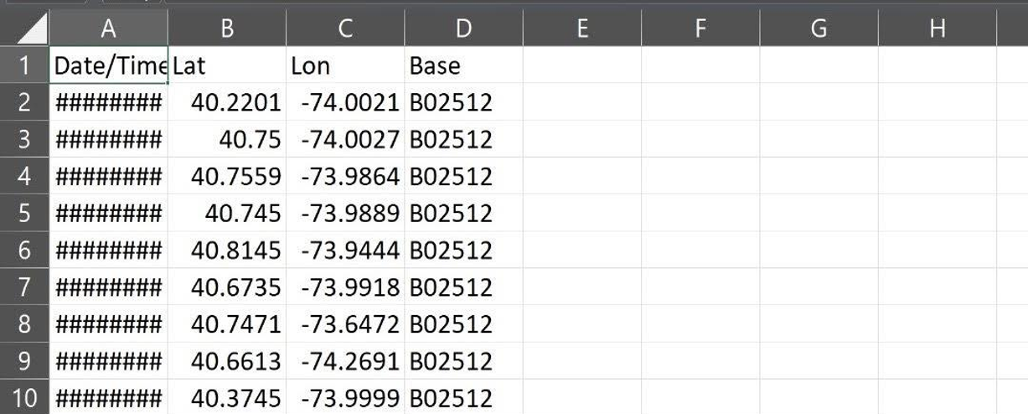

**OUTPUTS**

**Distribution of hour of the day :**

The seaborn distribution plot (`sns.distplot(data["Hour"])`) for the "Hour" column visualizes the distribution of trips across different hours of the day. The plot shows a histogram of trip frequencies for each hour, along with a curve representing the estimated density.

The plot can reveal trends in trip frequencies by hour, providing insights into peak and off-peak times for Uber services. Notable observations might include:

- Peak Hours: The plot may show clear peaks during certain hours, such as morning and evening rush hours, indicating higher demand for Uber rides during these times.

- Low Demand Hours: Certain hours, such as late at night or early in the morning, may show lower trip frequencies, suggesting reduced demand during these times.

- Consistent Patterns: Regular patterns, such as consistent peaks and troughs each day, can highlight standard commuting times or daily routines of users.

Overall, the distribution plot provides valuable information on the hourly usage patterns of Uber services, which can guide decisions on resource allocation and scheduling to meet user demand.

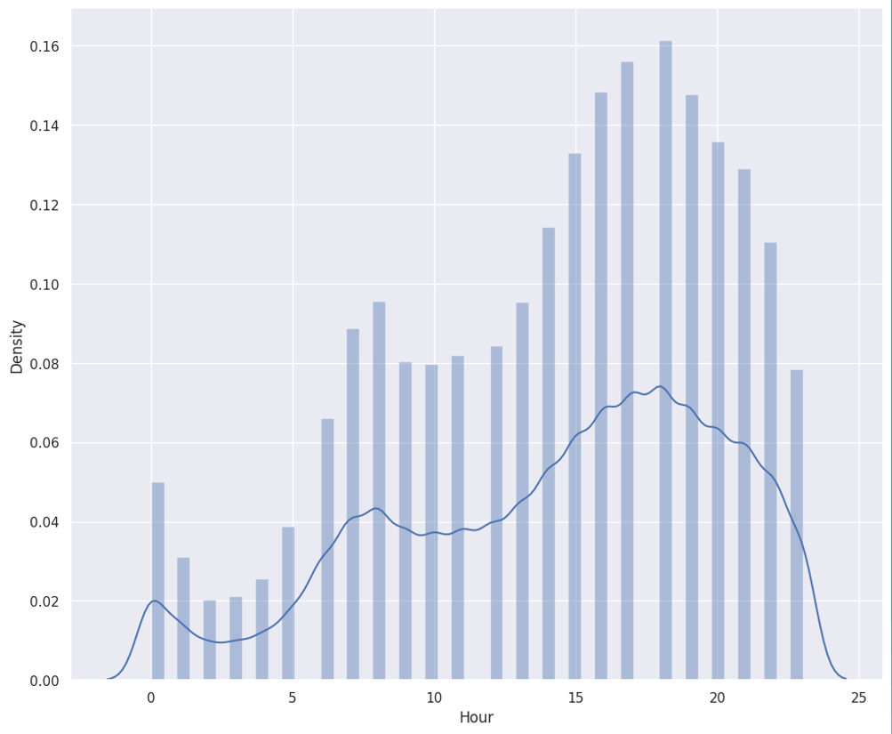

**HEAT MAP OF TRIPS BY HOUR AND WEEKDAY:**

